

**Lesson 4: Geometry Shapes with Colour Turtle Commands**

1. **Example #1 (Car Drawing)**

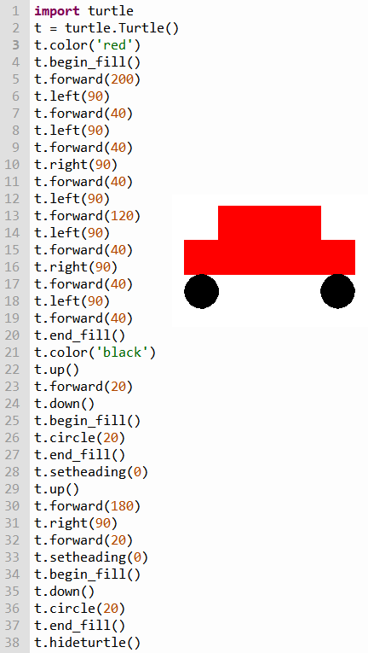

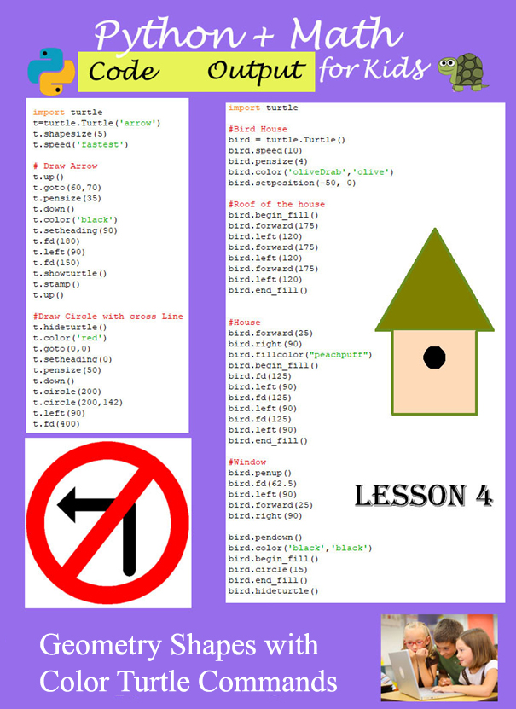

1. **Example #2** (Road Signs)

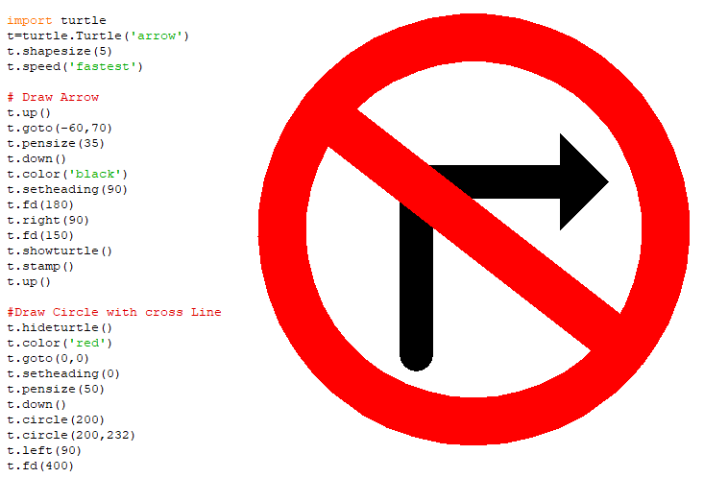

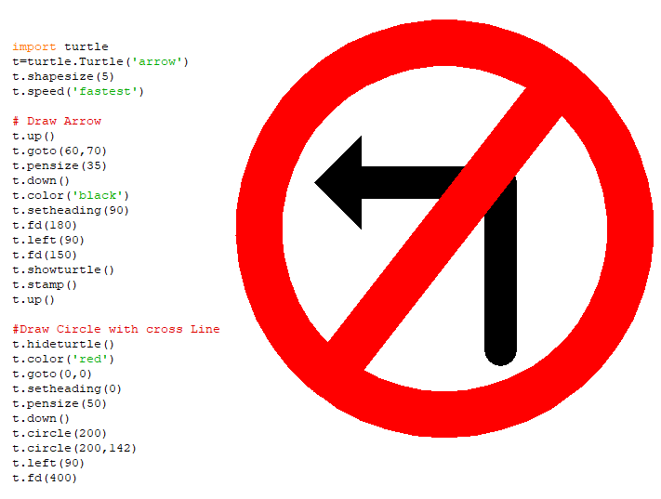

1. **Example #3** (Draw house)

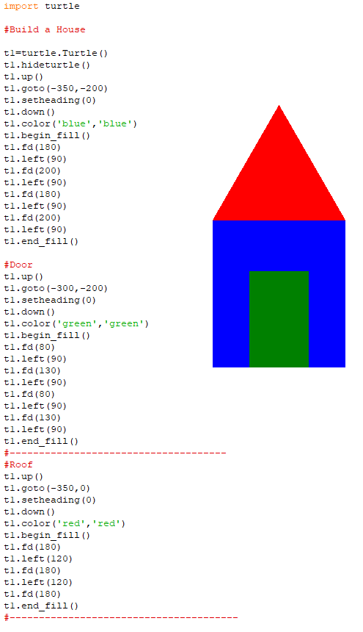

1. **Example #4** (Tree)

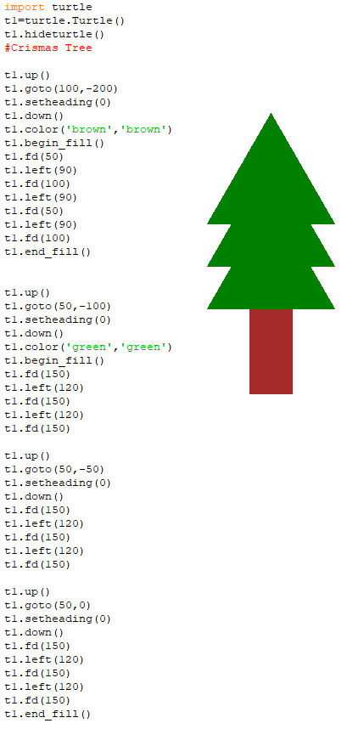

1. **Example #5** (Bird House)

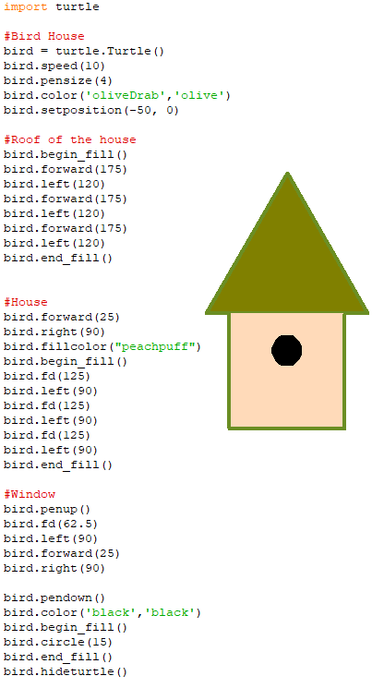

1. **Example #6**(Traffic Light)

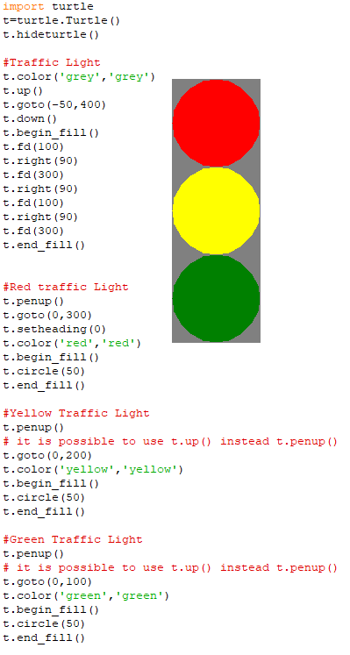

1. **Example #7** (Cat face)

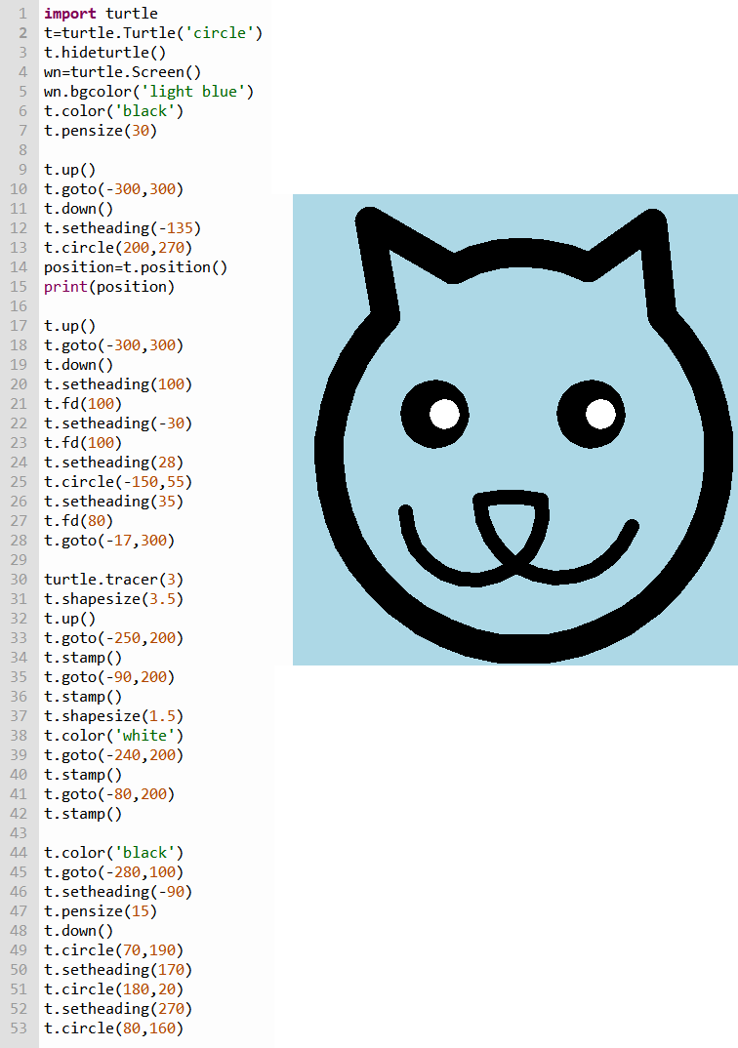

Challenges: write codes to create the following geometry shapes with circle code:

1. Expected output

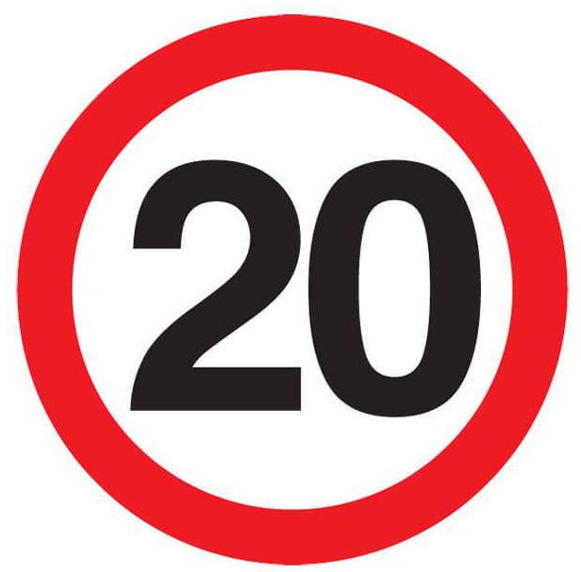

1. Expected output

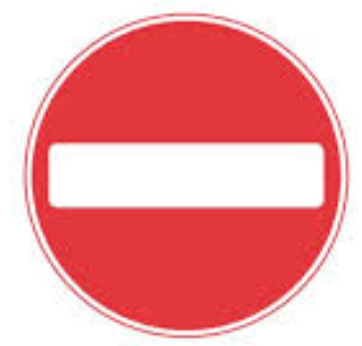

1. Expected output

